Skill – 3
(2400033340)

Project Structure
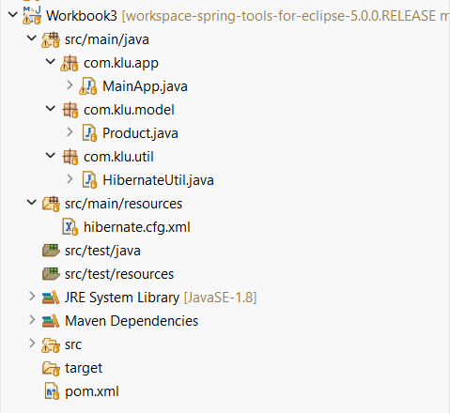

MainApp.java
package com.klu.app;

import java.util.*;
import org.hibernate.*;
import org.hibernate.query.Query;

import com.klu.model.Product;
import com.klu.util.HibernateUtil;

public class MainApp {

static Scanner sc = new Scanner(System.in);

public static void main(String[] args) {

int ch;
do {
System.out.println("\n=== WORKBOOK 2 : PRODUCT HQL MENU ===");
System.out.println("1. Insert Products");
System.out.println("2. Sort by Price (ASC)");
System.out.println("3. Sort by Price (DESC)");
System.out.println("4. Sort by Quantity (High → Low)");
System.out.println("5. Pagination");
System.out.println("6. Aggregate Functions");
System.out.println("7. Group By Description");
System.out.println("8. Filter by Price Range");
System.out.println("9. LIKE Queries");
System.out.println("0. Exit");

System.out.print("Enter choice: ");
ch = sc.nextInt();

switch (ch) {
case 1: insertProducts(); break;
case 2: sortPriceAsc(); break;
case 3: sortPriceDesc(); break;
case 4: sortByQuantity(); break;
case 5: pagination(); break;
case 6: aggregates(); break;
case 7: groupByDescription(); break;
case 8: filterByPriceRange(); break;
case 9: likeQueries(); break;
}
} while (ch != 0);
}
static void insertProducts() {
Session s = HibernateUtil.getSessionFactory().openSession();
Transaction tx = s.beginTransaction();

System.out.print("Name: ");
sc.nextLine(); // clear buffer
String name = sc.nextLine();

System.out.print("Description: ");
String desc = sc.nextLine();

System.out.print("Price: ");
double price = sc.nextDouble();

System.out.print("Quantity: ");
int qty = sc.nextInt();

Product p = new Product(name, desc, price, qty);
s.persist(p);

tx.commit();
s.close();

System.out.println("Product inserted successfully!");
}
static void sortPriceAsc() {
Session s = HibernateUtil.getSessionFactory().openSession();

Query<Product> q = s.createQuery(
"from Product order by price asc", Product.class);

q.list().forEach(p ->
System.out.println(p.getName() + " → " + p.getPrice()));

s.close();
}
static void sortPriceDesc() {
Session s = HibernateUtil.getSessionFactory().openSession();

Query<Product> q = s.createQuery(
"from Product order by price desc", Product.class);

q.list().forEach(p ->
System.out.println(p.getName() + " → " + p.getPrice()));

s.close();
}
static void sortByQuantity() {
Session s = HibernateUtil.getSessionFactory().openSession();

Query<Product> q = s.createQuery(
"from Product order by quantity desc", Product.class);

q.list().forEach(p ->
System.out.println(p.getName() + " → Qty: " + p.getQuantity()));

s.close();
}
static void pagination() {
Session s = HibernateUtil.getSessionFactory().openSession();

System.out.print("Enter starting index: ");
int start = sc.nextInt();

System.out.print("Enter number of records: ");
int size = sc.nextInt();

Query<Product> q = s.createQuery("from Product", Product.class);
q.setFirstResult(start);
q.setMaxResults(size);

q.list().forEach(p ->
System.out.println(p.getId() + " | " + p.getName()));

s.close();
}
static void aggregates() {
Session s = HibernateUtil.getSessionFactory().openSession();

System.out.println("Total Products: " +
s.createQuery("select count(*) from Product").uniqueResult());

System.out.print("Enter minimum quantity: ");
int q = sc.nextInt();

System.out.println("Products with quantity > " + q + ": " +
s.createQuery("select count(*) from Product where quantity > :q")
.setParameter("q", q)
.uniqueResult());

Object[] minMax = (Object[]) s.createQuery(
"select min(price), max(price) from Product").uniqueResult();

System.out.println("Min Price: " + minMax[0]);
System.out.println("Max Price: " + minMax[1]);

s.close();
}
static void groupByDescription() {
Session s = HibernateUtil.getSessionFactory().openSession();

List<Object[]> list = s.createQuery("select description, count(*) from Product group by description").list();

for (Object[] row : list) {
System.out.println(row[0] + " → " + row[1]);
}

s.close();
}
static void filterByPriceRange() {
Session s = HibernateUtil.getSessionFactory().openSession();

System.out.print("Enter min price: ");
double min = sc.nextDouble();

System.out.print("Enter max price: ");
double max = sc.nextDouble();

Query<Product> q = s.createQuery(
"from Product where price between :min and :max", Product.class);

q.setParameter("min", min);
q.setParameter("max", max);

q.list().forEach(p ->
System.out.println(p.getName() + " → " + p.getPrice()));

s.close();
}
static void likeQueries() {
Session s = HibernateUtil.getSessionFactory().openSession();

System.out.println("\n--- LIKE Queries ---");
System.out.println("1. Names starting with letters");
System.out.println("2. Names ending with letters");
System.out.println("3. Names containing substring");
System.out.println("4. Names with exact length");

System.out.print("Choose option: ");
int ch = sc.nextInt();
sc.nextLine();

Query<Product> q = null;

switch (ch) {
case 1:
System.out.print("Enter starting letters: ");
q = s.createQuery(
"from Product where name like :p", Product.class);
q.setParameter("p", sc.nextLine() + "%");
break;

case 2:
System.out.print("Enter ending letters: ");
q = s.createQuery(
"from Product where name like :p", Product.class);
q.setParameter("p", "%" + sc.nextLine());
break;

case 3:
System.out.print("Enter substring: ");
q = s.createQuery(
"from Product where name like :p", Product.class);
q.setParameter("p", "%" + sc.nextLine() + "%");
break;

case 4:
System.out.print("Enter exact length: ");
q = s.createQuery(
"from Product where length(name)=:l", Product.class);
q.setParameter("l", sc.nextInt());
break;

default:
System.out.println("Invalid choice");
s.close();
return;
}

q.list().forEach(p -> System.out.println(p.getName()));
s.close();
}
}

Product.java
package com.klu.model;
import javax.persistence.*;

@Entity
@Table(name="prod")
public class Product {

@Id
@GeneratedValue(strategy = GenerationType.IDENTITY)
private int id;

private String name;
private String description;
private double price;
private int quantity;

// ✅ Mandatory no-arg constructor
public Product() {}

// ✅ Constructor used in MainApp
public Product(String name, String description, double price, int quantity) {
this.name = name;
this.description = description;
this.price = price;
this.quantity = quantity;
}

public int getId() {
return id;
}
public void setId(int id) {
this.id = id;
}

public String getName() {
return name;
}
public void setName(String name) {
this.name = name;
}

public String getDescription() {
return description;
}
public void setDescription(String description) {
this.description = description;
}

public double getPrice() {
return price;
}
public void setPrice(double price) {
this.price = price;
}

public int getQuantity() {
return quantity;
}
public void setQuantity(int quantity) {
this.quantity = quantity;
}
}

HibernateUtil.java
package com.klu.util;
import org.hibernate.SessionFactory;
import org.hibernate.cfg.Configuration;

public class HibernateUtil {
private static SessionFactory factory;
static {
factory=new Configuration().configure("hibernate.cfg.xml").buildSessionFactory();
}
public static SessionFactory getSessionFactory() {
return factory;
}
}

hibernate.cfg.xml
<hibernate-configuration>
<session-factory>
<property name="hibernate.connection.diver_class">com.mysql.cj.jdbc.Driver</property>
<property name="hibernate.connection.url">jdbc:mysql://localhost:3306/Workbook_2</property>
<property name="hibernate.connection.username">root</property>
<property name="hibernate.connection.password">root</property>
<property name="hibernate.dialect">org.hibernate.dialect.MySQL8Dialect</property>
<property name="hibernate.hbm2ddl.auto">update</property>
<property name="hibernate.show_sql">true</property>
<mapping class="com.klu.model.Product"></mapping>
</session-factory>
</hibernate-configuration>

Output
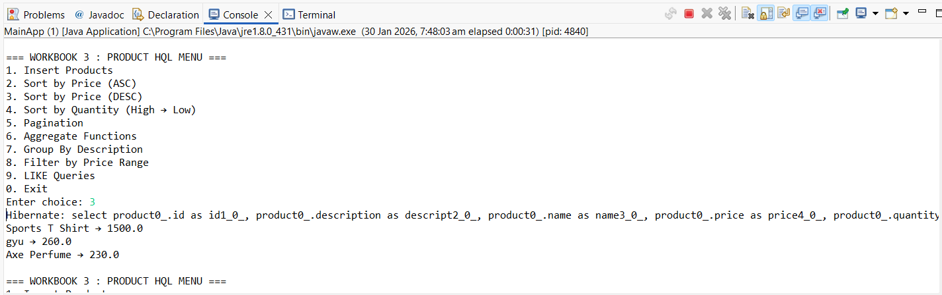

Viva Questions
- What is HQL and how does it differ from SQL?
- HQL (Hibernate Query Language) is an object-oriented query language that works on entities and their properties, whereas SQL works directly on database tables and columns.

- Why do we use sorting in HQL?
- Sorting in HQL is used to retrieve data in a specific order (ascending or descending) based on one or more fields.

- What is pagination and where is it used?
- Pagination is the process of dividing large result sets into smaller chunks and is used to improve performance and user experience.

- Name any three aggregate functions supported in HQL.
- Three aggregate functions supported in HQL are count(), sum(), and avg().

- What is the difference between HQL and HCQL (Hibernate Criteria Query Language)?
- HQL is string-based and database-independent, while HCQL (Criteria API) is object-oriented and allows building queries dynamically without writing query strings.

